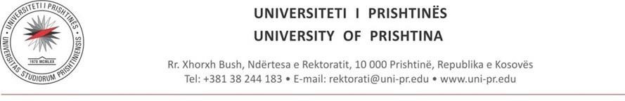

https://__________.uni-pr.edu/

SECTION: Advisory Board (AB) (Standard Structure)
Advisory Board (AB)
- Dean’s Welcome Message
- General Overview
- Mission
- Role and Functions
- Composition
- Duties and Responsibilities
- Operating Modalities
- Contribution to the Development of the Academic Unit
- Members of the Advisory Board
- Cooperation with the Career Development Center
- Official Documents

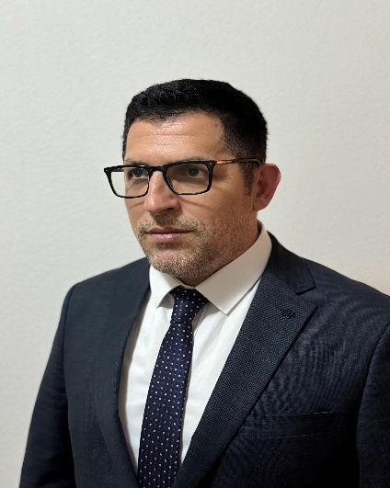
Assoc. Prof. Kajtaz Bllaca
Dean of the Faculty of Mathematics and Natural Sciences
"On behalf of the Faculty of Mathematical and Natural Sciences, I express my sincere gratitude and appreciation to the Advisory Board for their continuous and valuable contribution to the advancement of our faculty’s academic, scientific, and professional activities. Your engagement has significantly impacted the improvement of teaching quality, the updating of study programs, and the strengthening of the connection between scientific training and labor market demands, as well as collaboration with external partners. We highly value your readiness for ongoing support and reaffirm our institutional commitment to further strengthening and developing this important advisory mechanism."
General Overview
The Faculty of Mathematical and Natural Sciences is an academic unit dedicated to the development of higher education, scientific research, and professional training in the fields of chemistry, biology, mathematics, physics, and geography. The Faculty aims to offer contemporary study programs based on academic and scientific standards, promoting critical thinking, innovation, and preparing students for labor market challenges and the sustainable development of society.
The Faculty’s Advisory Board consists of experts from both academic and professional fields, who contribute directly to enhancing the quality of teaching, updating study programs, and strengthening the Faculty’s connection with the labor market and external partners. Through their experience, the Board supports the sustainable development and strategic orientation of the Faculty.

Mission
The mission of the Faculty of Mathematical and Natural Sciences is to develop scientific knowledge and provide quality education, training competent and responsible professionals capable of meeting academic and labor market challenges. The mission of the Advisory Board is to support this process through professional guidance, updating study programs, and strengthening the Faculty’s connection with the professional environment and external partners.

Role and Functions

The role and function of the Advisory Board consist of providing professional guidance for the academic and scientific development of the Faculty, with a focus on improving study programs and enhancing the quality of teaching. Thanks to their advice and experience, we offer students solid professional preparation, equipping them for real-world jobs and challenges in their respective industries. This collaboration has had a significant impact on the development of our accredited programs – currently 21 different programs – where meetings and consultations with the Advisory Board have generated valuable ideas and suggestions on the best ways to enhance academic quality and prepare students in accordance with labor market demands and societal needs.

ADVISORY BOARD (AB)
1.General Overview

The Advisory Board (AB) is a consultative body operating within the Faculty of Mathematics and Natural Sciences at the University of Prishtina. It contributes to the academic, professional, and strategic development of study programs. The Advisory Board serves as a bridge between higher education, the labor market, and contemporary developments in the relevant academic and professional fields.

2. Mission

The mission of the Advisory Board of the Faculty of Mathematics and Natural Sciences is to support the academic unit in enhancing the quality of teaching and the relevance of study programs through professional and academic advice grounded in experience and expertise.

3. Role and Functions
The Advisory Board of the Faculty of Mathematics and Natural Sciences has an advisory and recommendatory role, contributing to:
- the development and review of study programs,
- alignment of curricula with labor market needs,
- identification of emerging academic and professional trends,
- improvement of students’ professional preparedness, and
- strengthening cooperation with public and private sector stakeholders.
4. Composition
The Advisory Board of the Faculty of Mathematics and Natural Sciences consists of:
- representatives of the academic staff of the faculty,
- representatives of public institutions,
- representatives of the private sector and industry,
- professionals and experts in the relevant field,
- representatives of students and alumni.
The composition of the Advisory Board ensures a balanced combination of academic expertise and practical experience.
5. Duties and Responsibilities
The main duties of the Advisory Board of the Faculty of Mathematics and Natural Sciences include:
- providing recommendations for the improvement of study programs,
- advising on professional competencies required by the labor market,
- supporting initiatives related to professional practice and employability,
- contributing to the development of career-related policies and mechanisms, and
- offering expertise in accreditation and self-evaluation processes.
6. Operating Modalities
The Advisory Board of the Faculty of Mathematics and Natural Sciences meets periodically, typically once or twice per year, or as needed by the academic unit. Meetings are organized in cooperation with the faculty management and are intended to facilitate discussion and provide concrete recommendations.
7. Contribution to the Development of the Academic Unit
Through their engagement, the Advisory Board of the Faculty of Mathematics and Natural Sciences contributes to:
- improving academic quality,
- enhancing graduate employability,
- strengthening the link between the university and the labor market, and
- advancing the institutional profile of the academic unit.
8. Members of the Advisory Board

- Afrim Berisha
Chair of the Advisory Board
Head of the Department for Environmental State Assessment / Ministry of Environment and Spatial Planning
Doctor of Technical Sciences
2018–2026
Afrim Berisha holds a PhD in Technical Sciences, with a Master’s degree in Biology and a specialization in Ecology and Environmental Protection. He completed his undergraduate studies at the University of Prishtina and earned his doctoral degree at Ss. Cyril and Methodius University in Skopje, at the IZIS Institute.
He has over two decades of professional experience in the environmental sector, primarily within the Ministry of Environment and Spatial Planning and the Environmental Protection Agency, where he has held leadership roles in the management of environmental reports, plans, and programs, as well as in environmental state assessment. He currently serves as Head of the Department for Environmental State Assessment and as the National Reference Center for Cooperation and Coordination within the European Environment Agency framework.
His areas of expertise include environmental management, environmental policy, climate change, biodiversity, water and waste management, greenhouse gas inventories, environmental impact assessment, and European integration processes. In January 2025, he was elected Chair of the Advisory Board of the Faculty of Mathematical and Natural Sciences.
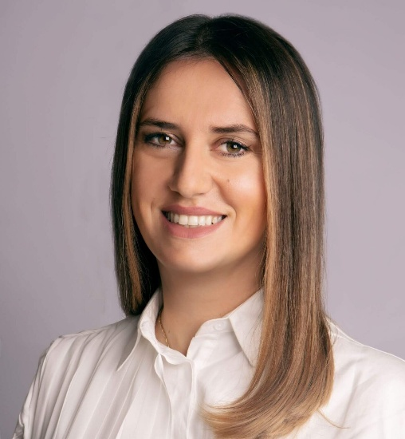
- Abetare Gojani
Member of the Advisory Board
Executive Director / The Foundation House
MBA, Staffordshire University
Abetare Gojani is the Executive Director of The Foundation House (formerly known as IPKO Foundation), where for more than a decade she has led high-impact initiatives in education, technology, and youth empowerment in Kosovo. She holds an MBA degree from Staffordshire University and is certified as an ISO/IEC 42001 AI Management System Lead Implementer, Certified Digital Transformation Expert (CDTE), and ISO 20700 Practitioner. She has also completed professional PMP training, along with advanced programs in project management, design thinking, and leadership.
Throughout her career, Abetare has been a strong advocate for the promotion of women and girls in STEM, leading national initiatives such as Girls in ICT and International Girls’ Day, as well as co-developing DOKU.TECH, one of the most influential technology events in Kosovo. She is also a member of Women in Tech Kosovo and serves as a civil society representative at the Office of Good Governance of the Republic of Kosovo.
Under her leadership, The Foundation House has received national recognition and awards, including the FIDES Award and a Certificate of Appreciation from the CSR Network in Kosovo, reflecting her strong commitment to advancing digital inclusion, experiential learning, and community-driven innovation.


- Edona Aliu Hasani
Member of the Advisory Board
Specialist for Institutional and Private Clients / Business Banking
Master of Science in Economics – Marketing
https://www.linkedin.com/in/abetare-gojani-2a784264/
Edona Aliu Hasani is a professional with extensive experience in the financial and banking sector, with over 14 years of continuous engagement in a banking-level financial institution. Throughout her career, she has built a solid professional profile by contributing across various areas and sectors of the bank, with a particular focus on institutional and private banking.
Her experience includes hands-on work in financial analysis, performance monitoring, relationship management, and coordination between branch offices and central bank structures, as well as the preparation and analysis of daily, monthly, and annual periodic reports that serve as a foundation for strategic and operational decision-making.
A significant part of her professional engagement is related to the institutional and private sector, where she has held responsibilities for monitoring institutional clients, including the analysis of transactions, deposits, financial flows, and client market behavior. Through this work, she has contributed to identifying market trends, assessing risks and opportunities, and providing pricing structures and tailored solutions for institutional and private clients.
Her work has been characterized by continuous collaboration with various departments within the bank, such as marketing, product development, and risk management, with the aim of improving banking products and services in line with market needs. Additionally, she has been involved in coordinating and managing relationships with financial institutions and funds through performance reporting and analysis.
From a professional standpoint, Edona Aliu Hasani is recognized for her analytical approach, commitment to work quality, and ability to bridge theory with practice. Her extensive experience in the banking sector makes her a valuable advisory voice, particularly in connecting the academic world with the practical realities of the financial system.
Her engagement as a member of the Advisory Board at the Faculty of Mathematics represents an opportunity to contribute to the academic and professional development of students by bringing practical experience from the financial sector and supporting the development of competencies required by today’s labor market.
• Agron Shala
Member of the Advisory Board
Deputy Director of KHMI / Kosovo Hydro meteorological Institute
Master’s Degree in Analytical and Environmental Chemistry
• Fetah Krasniqi
Member of the Advisory Board
Meteorology Expert at the State Civil Aviation Agency
Master’s Degree
• Flamur Kadriu
Member of the Advisory Board
FVA
• Agon Kabashi
Member of the Advisory Board
Manager of Strategic Initiatives / Raiffeisen Tech
• Gentrit Gojani
Member of the Advisory Board
Chief Technology Officer / Kode LABS
• Fadil Bajraktari
Member of the Advisory Board
Director of the Institute for Nature Protection / Environmental Protection Agency of Kosova
Master’s Degree
• Osman Hasku
Member of the Advisory Board
Head of Production and Quality Control / Kosova Wine
Master’s Degree
• Ismajl Baftijari
Member of the Advisory Board
Institute for Science and Technology (INSI)
• Shpendim Shabani
Member of the Advisory Board
M & Sillosi
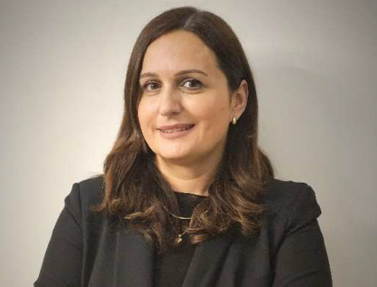
• Vjosa Sherifi
Member of the Advisory Board
Operations Manager / National Commercial Bank (BKT)
Master of Science in Economics – Management and Informatics
https://www.linkedin.com/in/vjosa-sherifi-berisha-ab6207140
Vjosa Sherifi is a professional with extensive experience in the banking sector and operational management. Since 2007, she has been engaged at the National Commercial Bank in Prishtina, where she holds the position of Operations Manager at the Pejton Branch. In this role, she is responsible for planning and overseeing daily banking operational activities, implementing internal policies and procedures, ensuring compliance with banking legislation and regulations, as well as identifying and managing operational risk. She leads and develops operational staff, ensures high service quality, and initiates process improvement and digitalization projects, while also ensuring the implementation of business continuity plans.
Throughout her professional career, Ms. Sherifi has achieved significant results in optimizing operational processes, increasing efficiency, and reducing the processing time of banking operations. She has ensured full compliance with banking regulations and internal policies, proactively managed operational risk, and contributed to reducing incidents and potential losses. Through effective leadership, she has supported the professional development of staff and improved overall performance and service quality.
Vjosa Sherifi completed her Bachelor’s studies in Economics and earned a Master of Science in Economics in Management and Informatics at the University of Prishtina, Faculty of Economics. In addition, she is certified as an Accounting Technician by the KAF Institute.
As of 15 November 2025, Vjosa Sherifi has been a member of the Advisory Board of FMNS, based on Decision No. 5730. Her mandate is for a two-year term, with the possibility of extension, during which she contributes her professional experience and expertise in support of the mission and objectives of FMNS.
• Arsim Sogojeva
Member of the Advisory Board
Kosovo Cadastral Agency
• Erblind Musliu
Member of the Advisory Board
Student, FMNS
9. Cooperation with the Career Development Center
https://uni-pr.edu/page.aspx?id=1,77
The Advisory Board of the Faculty of Mathematics and Natural Sciences works closely with the Career Development Center (CDC) of the University of Prishtina in:
- identifying labor market needs and required professional competencies,
- developing internship programs and employment opportunities for students and graduates,
- involving employers in career orientation and counseling activities, and
- supporting employability initiatives and the transition from studies to the labor market.
This cooperation aims to establish sustainable career development mechanisms within academic units.
10. Official Documents (Optional)
- Decision on the establishment of the Advisory Board
- Rules of Procedure
- Meeting agendas and summary reports
- Recommendations
- Other relevant documents

